Full Recording

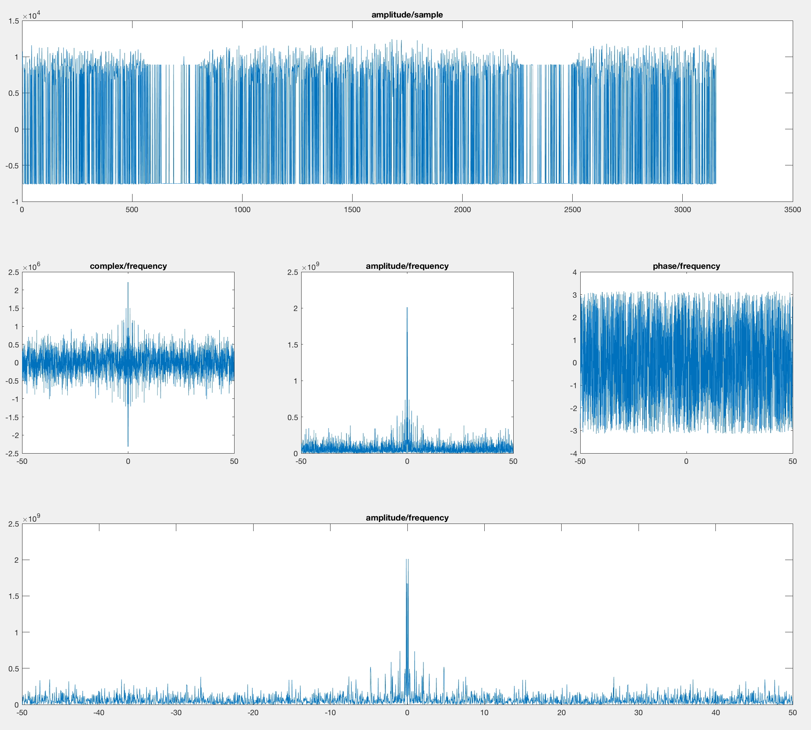

Wave detected and processed

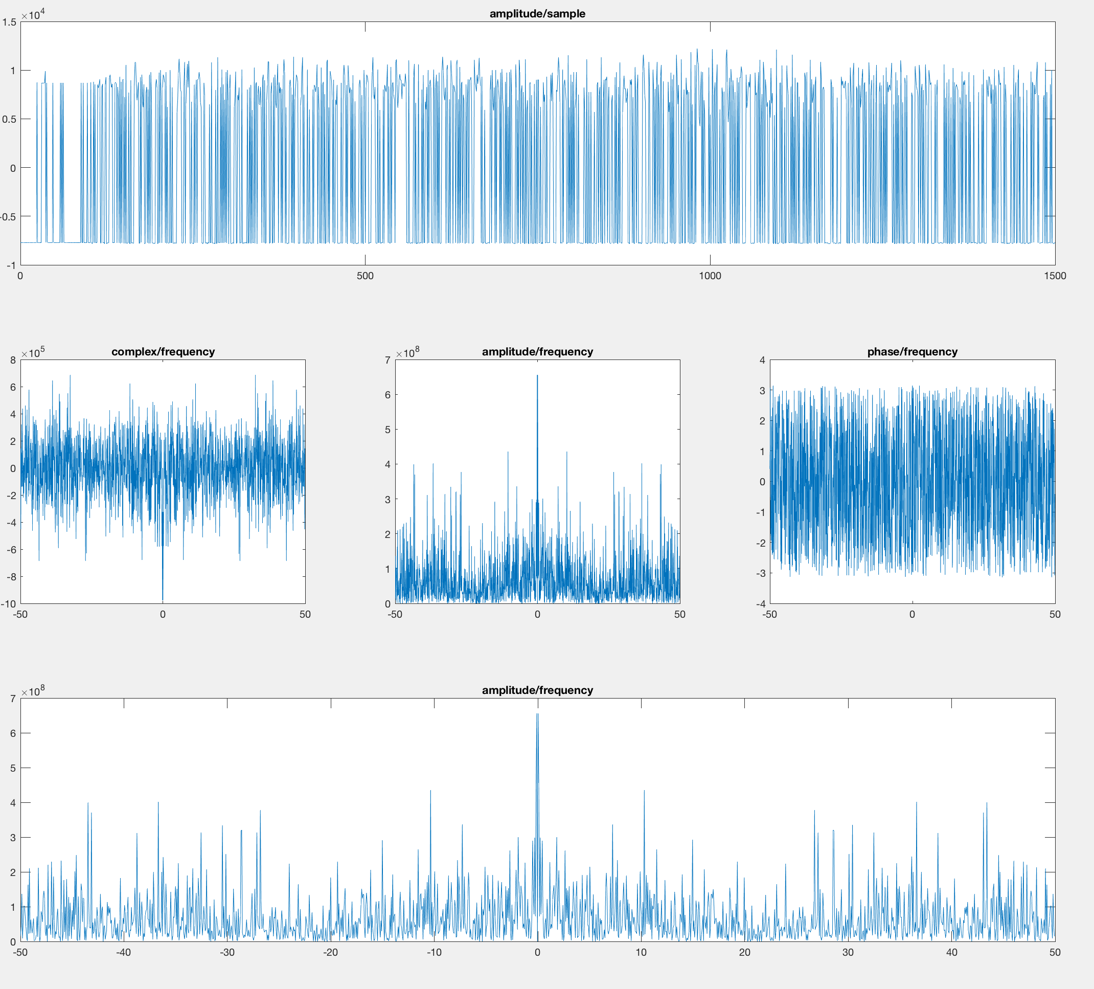

**Frequencies**

11Hz, 7Hz

**Total wave**

1400 samples -> 29.974 seconds. -> ~= 30 seconds

**Pause**

2500 - 2250 = 250 samples.

(250/1400)*30 = 5.357 seconds -> ~= 5.3 seconds